Patient:
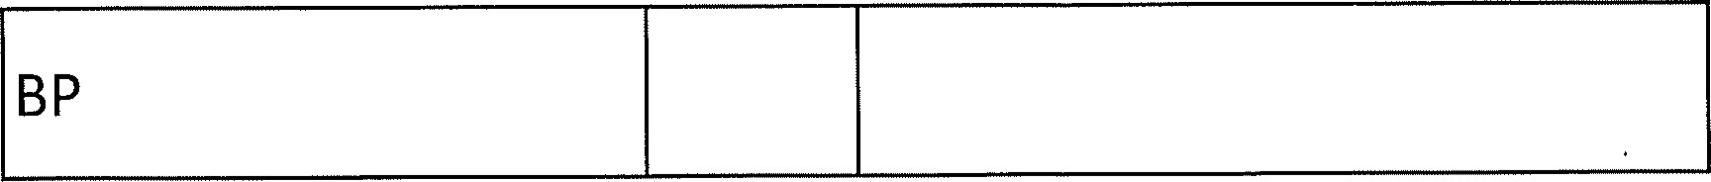
Height
Weight
Smoking Status
Alcohol consumption
Comments

